ITCR Training and Outreach Working Group Meeting

Thursday, March 14, 2019
4:00 - 5:00 PM Eastern Time

Agenda

- JCO CCI special ITCR issue survey results
  - Link to results (names have been removed).

- Roundtable discussion regarding documentation approaches, including (but not limited to)
  - Documentation tools
    - Format of the content (“generic”: ASCIIdoc, others - Markdown, ReStructuredText (RST), platform-specific: GitBook)
    - Platform for hosting the content - user facing
    - Platform for hosting the content - maintainer facing
    - (popular?) Available platforms for maintaining and hosting documentation:
      - GitBook: https://www.gitbook.com/ (e.g., used by several ITCR projects, see examples:
        - https://qiicr.gitbooks.io/dcmqi-guide/
        - https://docs.ohif.org/
        - https://ucsc-xena.gitbook.io/project/
      - ReadTheDocs: https://readthedocs.org/; used by several ITCR projects, examples:
        - https://digitalslidearchive.github.io/HistomicsTK/index.html (RST-based)
        - https://dicom4qi.readthedocs.io/en/latest/ (markdown-based)
        - 3D Slicer: https://slicer.readthedocs.io/en/latest/ (RST-based)
      - MkDocks: https://www.mkdocs.org/
      - Asciidoc: https://asciidoctor.org
        - For converting files: https://asciidocfx.com
        - ITCR project using Asciidoc:
          - EMERSE: http://project-emerse.org/documentation/index.html
      - WikiMedia; examples:
        - 3D Slicer: https://www.slicer.org/wiki/Documentation/Nightly
      - Github built-in wiki
        - Examples from Trinity projects
          - InferCNV (docs just overhauled this week w/ new release)
https://github.com/broadinstitute/infercnv/wiki
          - Trinity Assembly: https://github.com/trinityrnaseq/trinityrnaseq/wiki
          - STAR-Fusion: https://github.com/STAR-Fusion/STAR-Fusion/wiki
          - And others… Trinity-CTAT is a good starting place: https://github.com/NCIP/Trinity_CTAT/wiki
          - We love github-wiki!! :-)
          - One thing I do not like about github-wiki is how cumbersome it is to insert images there … I complained to their support, and they gave me a nice workaround (just in case it can help someone):
- 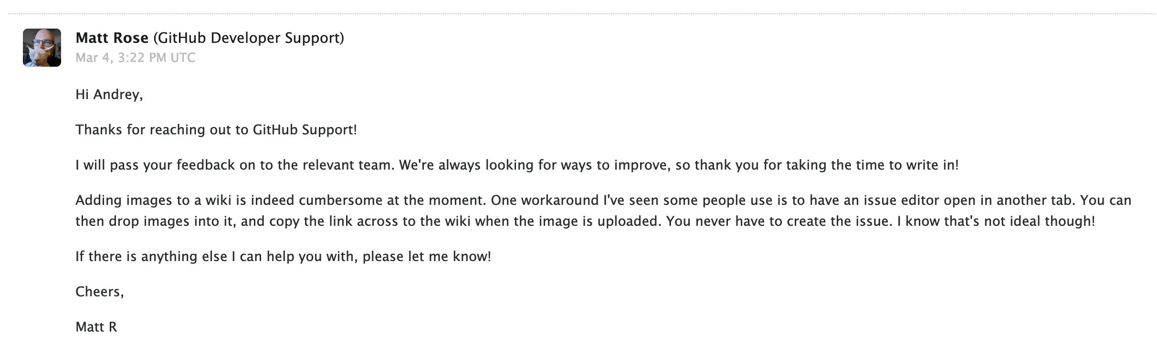
      - Jupyter Notebook
        - QIICR project experience: good tool for preparing materials for a conference tutorial
          - Notebooks source code here: https://github.com/QIICR/dicom4miccai-handson/tree/master/notebooks
          - Rendered notebook on nbviewer: https://nbviewer.jupyter.org/github/QIICR/dicom4miccai-handson/blob/master/notebooks/headneck.ipynb
          - There is also binder to run notebooks on a VM (for free!): https://mybinder.org/ (can also be done with Azure: https://docs.microsoft.com/en-us/azure/notebooks/tutorial-create-run-jupyter-notebook, and now with Google Colab: https://colab.research.google.com/notebooks/welcome.ipynb )
        - The ITCR-funded GenePattern Notebook environment, http://notebook.genepattern.org, is a cloud-based JupyterHub server that allows users to create and run Jupyter Notebooks with a number of extensions for bioinformatics analysis and visualization
        - I thought Cytoscape also is heavily based on Jupyter Notebook, but I may be confusing with another project ...
      - Google docs
  - Keeping documentation up to date
    - Including screenshots as the UI changes
  - How to write for the right audience(s) [users vs developers vs others]
  - Length/details -- how much is needed, can there ever be too much?
    - AF: yes (it can become obsolete, it will be a problem if there is no good way to search it)
  - Where/how to host it?
    - Within the app?
    - On a separate web page?
  - How to make it searchable?
    - For EMERSE, http://www.tipue.com/search/ has worked well.
    - GitBook allows for searching
    - ReadTheDocs - need to either host a server or you can use the main site, but then have to link to the site (taking people away from the main project site).
  - How to incorporate it into the general website (formatting, menus, etc).
  - Who is allowed to edit the documentation (users, anyone), and who would oversee the changes

Upcoming Meetings

April 2018: Presentation by Serghei Mangul on his recent paper, “ A comprehensive analysis of the usability and archival stability of omics computational tools and resources”, followed by an open discussion.
http://www.sergheimangul.com
https://www.biorxiv.org/content/biorxiv/early/2018/10/25/452532.full.pdf

May 2018: Presentation by Jeffrey Leek from Johns Hopkins, regarding MOOCs, including technology used for text to speech to automate the development/maintenance of MOOC videos.

Webex Information:

JOIN WEBEX MEETING
https://cbiit.webex.com/cbiit/j.php?MTID=m90b62cf4b0ffc9b0c9e13b53425cc602
Meeting number (access code): 733 094 302

JOIN BY PHONE
1-650-479-3207 Call-in toll number (US/Canada)

Global call-in numbers:
https://cbiit.webex.com/cbiit/globalcallin.php?serviceType=MC&ED=574640482&tollFree=0

Prior Meeting Notes: NCIP Hub

Feedback about meeting or suggestions for future meetings: Anonymous Qualtrics Survey

Outreach Activities Since Last Meeting (please fill in with new rows)
Name | Tool | Description of Activity
David Hanauer | EMERSE | Bio-IT World, San Francisco, presentation
Michael Reich | GenePattern Notebook | UCSF, Full-day workshop  Stanford, talk and half-day workshop  BioIT World, San Francisco, presentation
Mary Goldman | UCSC Xena | City of Hope, Full-day workshop  UCSC, two 2-hour class workshops
Mike Ryan | JHU CRAVAT | Fred Hutchingson Hackathon - Seattle Data Science FHackathon
Brian Haas | Trinity-CTAT-Fusion | Seminar on experiences using Firecloud for processing TCGA, GTEx, and CCLE through STAR-Fusion

Tools people are playing around with for image upload/editing:
GitBook - Good for simple, non-technical uses
Other markdown editors: Atom.io
ReadTheDocs

Attendees, please sign in here:
David Hanauer, U of Michigan
Dinler Antunes, Rice University
Mark Moll, Rice University
Bradley Broom, MD Anderson
Mike Ryan, JHU
Michael Reich, UCSD
Mary Goldman, UC Santa Cruz
Tali Mazor, DFCI
Brion Sarachan, GE Global Research
Mervi Heiskanen, NCI
Hayley Dingerdissen, GW
Rudi Pillich, UCSD
Juli Klemm, NCI
Andrey Fedorov, BWH
Mo Heydarian, JHU/OHSU
Rick Bradshaw, University of Utah
David Gutman, Emory
Steve Jett, NCI
Betsy Hsu, NCI
Simina Boca, Georgetown
Brian Haas, Broad Institute

Minutes (everyone feel free to contribute):

