ITCR Monthly Meeting
May 6, 2016
2:00 - 3:00pm ET

Join the WebEx Meeting

Join by phone
1-855-244-8681 Call-in toll-free number (US/Canada)
1-650-479-3207 Call-in toll number (US/Canada)
Access code: 738 170 557

Reminder: Due to the large number of people on the call, it is important to put your phone on mute when not speaking. Please do not put your phone on Hold as this may broadcast on-hold music to the group.
To mute your phone within WebEx, hover over your name or phone number in the Participants list and click on the microphone icon on the far right.

Agenda

2:00 - 2:10 | General Updates | Juli Klemm
2:10 - 2:20 | Introduction of new grantees
2:20 - 2:50 | Informatics Needs of the NCI MCL Consortium | Dan Crichton, JPL
2:50 - 3:00 | Discussion | All
3:00 | Adjourn

Please enter your name and institution below:
Mervi Heiskanen, NCI
Juli Klemm, NCI
Tom Doak, IU
Tony Dickherber, NCI
Despina Kontos, UPenn
Bobbie-Jo Webb-Robertson, PNNL
Alex Krasnitz, CSHL
Eric Bernhard, NCI
Maureen Sartor, University of Michigan
Dan Marcus, Washington University
Timothy Tickle, Broad
Brian Haas, Broad
Mike Ryan, JHU / MD Anderson
Michael Reich, UCSD
Jingshan Huang, South Alabama
George Redmond, NCI
Tim Griffin, U of Minnesota
Grace Xiao, UCLA
Mary Goldman, UC Santa Cruz
Terry Meehan, EMBL-EBI
Metin Gurcan, OSU
Anant Madabhushi, CWRU
Dan Crichton, NASA/JPL
Lauren O’Donnell, BWH
Martin Morgan, RPCI
Rachel Karchin, Johns Hopkins
Guergana Savova, BCH/HMS
Miguel Ossandon
Bradley Broom, UT MD Anderson Cancer Center
Joel Saltz Stony Brook
Guoqian Jiang, Mayo Clinic
Hiro Yoshida, MGH/HMS
Anne Martel, SRI
Yantian Zhang, NCI
Helen Parkinson, EMBL- EBI
Hong Yu, Umass
Rebecca Jacobson, Pittsburgh
Dexter Pratt, UCSD

Notes:

Juli Klemm:
- AACR Meeting: ITCR Session, thank you speakers and organizers.
- Upcoming F2F meeting at the Broad June 13-14: deadline for booking hotel approaching, please register. Breakout rooms for lunch meetings. TOW lunch meeting on the 13th. June 14th open for lunch meeting, please contact Juli if you want to book the room.
- FireCloud workshop on June 15th: separate registration.

New Grantee Introductions:
- Tim Griffin, University of Minnesota: Galaxy, a web based genomic data analysis system. U24
- Rachel Karchin, John Hopkins University: The Cancer-Related Analysis of VAriants Toolkit (CRAVAT) and the Mutation Position Imaging Toolbox (MuPIT). U24.
- Helen Parkinson & Terry Meehan, EMBL-EBI: A central database (PDX Integrator) for all data related to patient derived xenograph (PDX) mouse models.U24
- Xinshu (Grace) Xiao, UCLA: informatics tools for RNA-seq data analysis at the single nucleotide level. U01
- Chakara Chennubhotla, University of Pittsburgh. Imaging tools to assess Intratumor heterogenity. U01

Dan Crichton, NASA JPL Presentation
dan.crichton@jpl.nasa.gov

Goal is to identify opportunities for collaboration between the ITCR program and the JPL Informatics Center.
Presentation posted on the NCIP Hub https://nciphub.org/groups/itcr/monthly_pi_teleconferences

Q: Models for programmatic interoperability.
A: RDF for data sources to unify ontology, rest APIs, web services.
Q: how much has been already developed? Open source?
A: everything in github, open source. Data infrastructure is in place. How to streamline approaches, more tools for labs and investigators needed.
Q: JNCI Reference: see below.
Q: Reproducibility scope?
A: Capturing enough detail in data repository to enable researchers to reproduce the results.Would like make the process more consistent, streamlined.
Q: common data elements, ontologies is a plus
A: Two separate groups, ontologies and IT. Intelligence of data management and discovery needs to be included. XML files tied to ontology.
Q: Semantics?
A: Ontologies and relationships between different objects. Data layer that describes relationships.
Q: Sparkle?
A: No Sparkle yet. Looking into it.
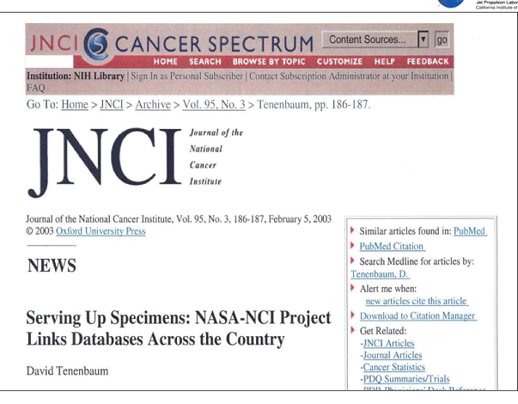

Meeting agendas/notes now available in a GoogleFolder
Meeting materials available on the NCIP Hub.
Website: http://itcr.nci.nih.gov
Hashtag: #nciitcr

