Pathologist Variability Detecting Mitoses
Brandon D. Gallas¹, Jamal Benhamida², Qi Gong¹, Matthew G. Hanna², Partha P. Mitra³, S. Joseph Sirintrapun² Kazuhiro Tabata², Yukako Yagi²
¹ FDA/CDRH/OSEL/DIDSR, Silver Spring, MD, US
² Memorial Sloan Kettering CC, New York, NY, US
³ Cold Spring Harbor Laboratory, Cold Spring Harbor, 11724, NY, US

Background
Supervised image analysis algorithms are only as good as the ground-truth on which they are trained. The most practical ground-truth for training an algorithm is a pathologist's assessment on whole slide images (WSIs). Inter-observer variability may affect the reliability of the algorithm. Annotations from WSIs are subject to other limitations, such as the inability to focus on nearby planes of a section (as can be done on a microscope). In this work, we conducted a preliminary feature analysis study detecting mitoses with WSI and with a microscope. This study provides candidate mitoses for a larger study to be conducted on a 14-head microscope. Data from the larger study will be used to evaluate the performance of an automated mitosis detection algorithm. Detecting and quantifying mitoses is an important pathology task when evaluating tumors in many organs; it is also challenging and burdensome to pathologists. Because such a task is likely to be impacted by scan quality, we also investigate its suitability for evaluating image quality.

Design
Four pathologists evaluated 40 regions of interest (ROIs) from 4 H&E slides on a microscope and the corresponding WSIs (Aperio AT2, 0.25um/pixel). We collected mitosis locations with a custom hardware and software evaluation environment for digital and analog pathology (eeDAP). eeDAP allows us to automatically present the same ROIs to the pathologist on the microscope or the WSI (See Figure). This removes significant variability associated with pathologists evaluating different areas of the slides. The ROIs in this study are 200 um x 200 um, which is equivalent to 800 x 800 pixels at 0.25 um/pixel.

Results
The pathologists identified 91 "candidate" mitoses in aggregate. We call them candidate mitoses because only 21 of 91 were unanimously identified. The standard error in the inter-reader difference in counts was larger for the WSI counts compared to the microscope counts (1.3 vs. 1.1) and on average the pathologists identified fewer mitoses on the WSI (49) compared to the microscope (59).

Conclusion
The preliminary study has provided an adequate list of candidate cells for the 14-head study.

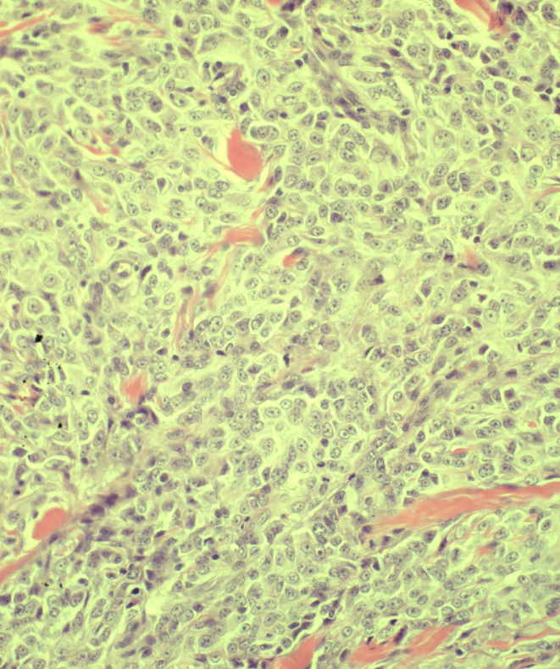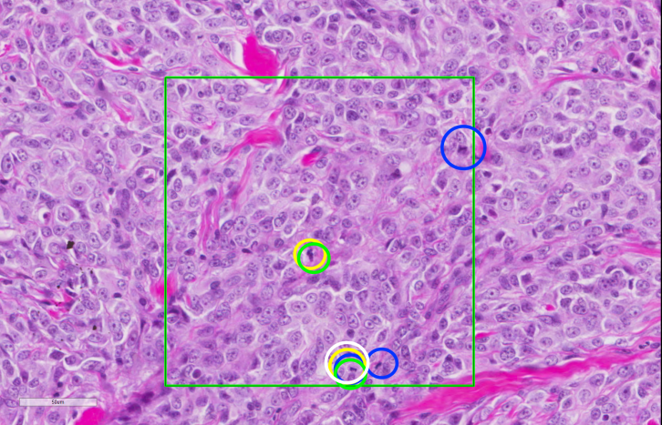
Figure 1. Representative matched comparison of WSI and microscope ROIs. WSI image shows the ROI outlined in green. Circles show mitoses identified by pathologists. Each color corresponds to a different pathologist. Camera image shows the central portion of the microscope FOV. The ROI is demarcated to the pathologist with a reticle in the eyepiece that is not seen by the camera.
WSI image
Camera image

